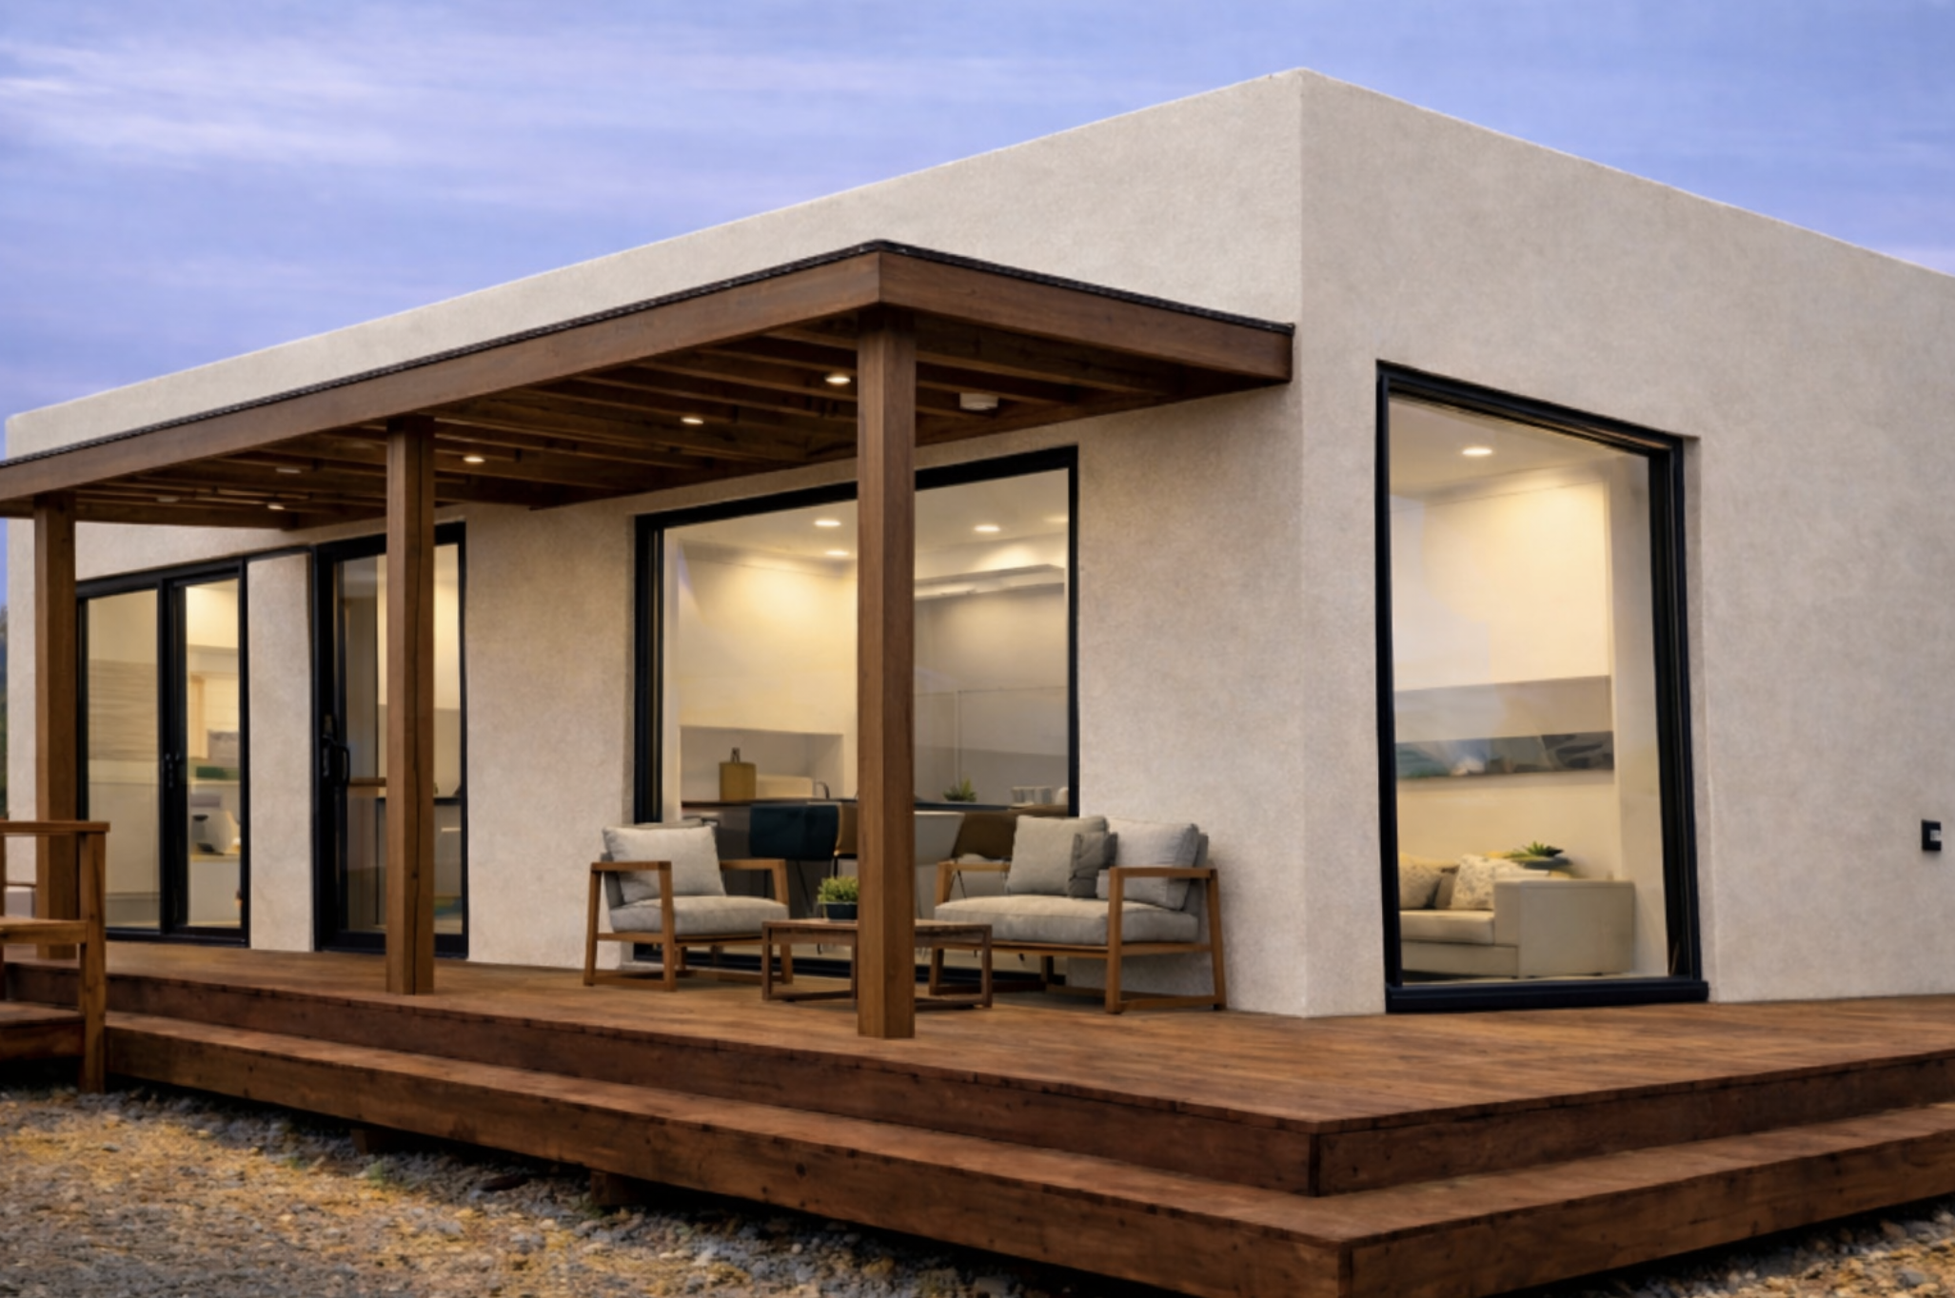 | ADU MODULAR HOMES is a builder of affordable homes, casitas, and accessory dwelling units. We also offer sustainable outdoor solar living products that can power the home. We partner with top rated factories, manufacturers and contractors to permit, design, build, and install your homes.  Our mission is to make the homebuilding process SIMPLE, EFFICIENT, and AFFORDABLE for our customers.

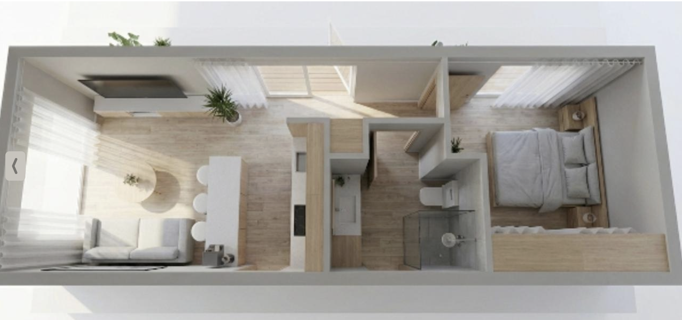

BASE PRICE: $150,000

SOLAR PATIO: Covered outdoor living space with integrated solar power generation $30,000
(federal tax credit) ($10,000)
TOTAL PRICE: $170,000

Date: 4-09-26

Dear Mr. and Mrs. Stewart:

I am pleased to present this proposal for the supply and delivery of a factory-built modular residential dwelling unit with an optional solar patio.

Scope of Work

Modular Unit:
- Fabrication
- Procurement and specifications
- QA/QC
- Factory inspections
- Transportation to site
- Installation and utility connections
- Punch list

Purchase Price:

Base Modular Unit (Delivered, does not include site improvements):
$140,000

Optional Upgrade

Solar Patio System (Optional Add-On):
- ARKA Energy solar patio / PowerGazebo system
- Approx. 2.4kW – 4.9kW output capacity
- Optional battery storage / Tesla Powerwall compatibility
- Increases property value and usable space
- Covered outdoor living space with integrated solar power generation

Optional Pricing:
Starting at $30,000 installed
$10,000 Credit / Refund
Year-over-year green power supply
The solar patio may qualify for a ~30% Federal Tax Credit, subject to eligibility and tax code.

Estimated Duration: 8–12 weeks
Delivery Date: TBD

Exclusions
Plans, permits, engineering, site work, landscaping, crane set, appliances, cabinets/countertops, and utility tie-ins unless otherwise specified.

Sincerely,
ADU Modular Homes

